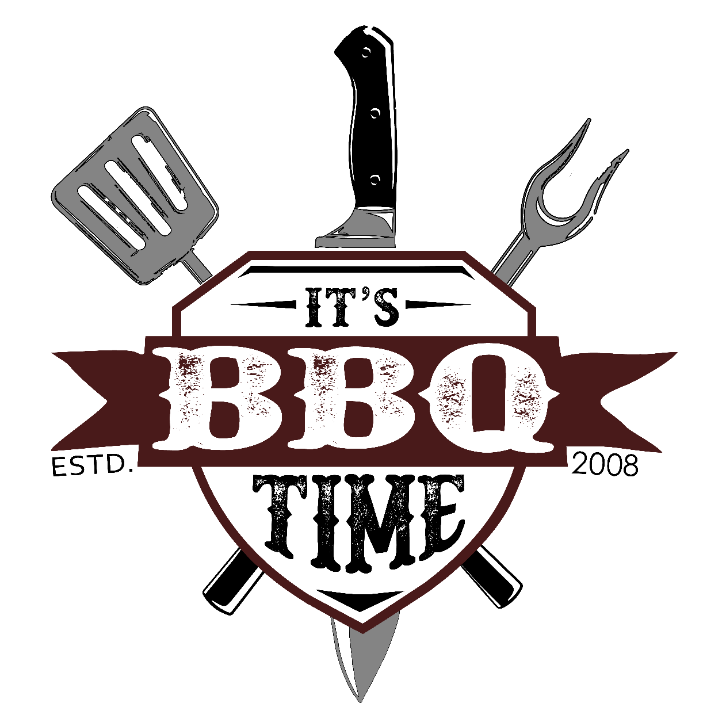

Phone: 503.582.2049

www.ItsBBQTimePDX.com

Thank you for your interest in It’s BBQ Time Catering & Event Management. To tell you a little about us, It’s BBQ Time Catering has 21 years experience catering all sizes and types of events –these have ranged from in home parties to large corporate affairs. We take pride in every event and it shows with our great food and friendly experienced staff.

It’s BBQ Time’s staff believes that each event should have its own style. We also believe that the menu and service provided should reflect that style – so we will work with each client to customize menus and levels of service to suit their needs and expectations.
In order to help make every event a success we also offer different levels of service – depending on your needs. These range from full service catering, food drop off, to wait staff or bartending only. We offer Day of Coordinating for your event. The wait staff service if for the client who would like to do the cooking but needs help with the setup and serving once the guests arrive.
Events that we specialize in are:
Corporate Events  Large BBQ’s and Meetings | Weddings & Rehearsal Dinners  Commitment Ceremonies- LGTB
Open Houses | Birthday Parties
Business Meetings &  Training Sessions | Theme Parties  Cocktail Eves
Employee Appreciations | Showers
Golf Tournaments | Formal & Informal Teas
Fund Raisers | Retirement Parties
Grand Openings | Reunions
Holiday Parties

A 20 % service charge (this is not the gratuity this is for food prep, fuel, overhead and insurance) will be added to all food and service items at the end of your event. This excludes drop-offs over $700.00. A 50% non-refundable deposit is required to reserve your date (this does not apply to Business food drop-offs) the remaining 50% is due 2 weeks prior to your event. We can work on a PO basis if you make arrangements. For your convenience we accept cash, checks and credit cards*(3.5% added to cover bank fees passed on to customer for the customer’s convenience). We are very happy to accept checks or cash at no additional charge. Please feel free to call us with any questions, or to discuss the details of your event. We also invite you to visit our website at www.ItsBBQTimePDX.com

Thank you,
Dan Dyrdahl - Event Manager Email: ItsBBQTimePDX.com
Facebook/ Instagram: @ItsBBQTimePDX

These prices are when added to a dinner menu. Please inquire for pricing for an appetizer buffet.

Cold Hors D'oeuvres
Our Specialty- Whole Smoked Salmon w/dill sauce (10-13 lb) larger at additional charge |  |  |  | $300.00
Small tray serves approx. 50 guests/ Large trays approx. 100 guests |  |  | small | large
Meat & Cheese Tray w/Rolls |  |  | $100.00 | $195.00
Imported Cheese & Crackers |  |  | $100.00 | $195.00
Imported Cheese & Fresh Fruit |  |  | $110.00 | $2.10.00
Cheese & Cracker Display |  |  | $95.00 | $185.00
Fresh Fruit Display |  |  | $100.00 | $195.00
Fresh Vegetables w/ranch dip |  |  | $100.00 | $195.00
Fresh Vegetables & Pickled Vegetables |  |  | $120.00 | $220.00
Jumbo Shrimp Cocktail |  |  | $175.00 | $340.00
Jumbo Shrimp & Crab Cocktail |  |  | $175.00 | $325.00
Tiny Tea Sandwiches (per dozen) |  |  | $10.00
Tortilla Pin Wheels (each) |  |  | $1.00

Salads
Fresh Green Salad |  |  | $1.50
Fresh Green Salad w/marinated artichoke hearts & feta cheese |  |  | $2.50
Caesar Salad |  |  | $2.50
Pasta Salad |  |  | $1.50
Macaroni Salad |  |  | $1.50
Potato Salad |  |  | $1.50
Creamy Pea Salad |  |  | $2.25
Crab Salad |  |  | $3.50
3 Bean Salad |  |  | $2.50
Jell-O Salad |  |  | $1.50
* Ask about having your salad recipe made for you
Hot Hors D'oeurves |  |  | Per 100 pieces
Meatballs - choice of Sweet & Sour, BBQ, Mushroom Gravy |  |  | $100.00
Chicken Wings - choice of Hot, Sweet & Sour, BBQ, Teriyaki |  |  | $125.00
Mini Quiche |  |  | $100.00
Stuffed Mushroom |  |  | $150.00
Sesame Chicken |  |  | $200.00
BBQ Pork w/hot mustard sauce |  |  | $150.00
Mini Egg rolls |  |  | $125.00
Potato Skins |  |  | $150.00
Frank Wraps |  |  | $150.00
Cocktail Wieners |  |  | $100.00

Higher End Hors D'oeuvres |  |  |  |  |  | Per 100 pieces
Rumaki- Bacon wrapped scallops or chicken livers w/water chestnuts |  |  |  |  |  | $200.00
Brie En Croute
Stuffed Foccia
Hot Artichoke Dip w/baguette |  |  |  |  |  | $250.00
Cozy Shrimp - Shrimp wrapped in spring rolls |  |  |  |  |  | $250.00
 |  |  |  |  |  | $250.00
Chicken & Pineapple Brochettes |  |  |  |  |  | $400.00
Deluxe Cold Canapés
Mini Cheesecake Tartlets
Assortment of Mini Desserts |  |  |  |  |  | $300.00
Chocolate Fondue – Milk, Dark, White Chocolate, Carmel
(see last page for pricing)
(Includes fresh & dried fruits, nuts, breads & cookies) |  |  |  |  |  | $300.00

Hors Oeuvre Buffet

Option #1
Meat and Cheese on Dollar size rolls
Teriyaki Meatballs
Imported and Domestic Cheese and Crackers
Fresh Fruit Display, Fresh Vegetable Crudités'
Assortment of nuts
20.00 per person

Option #2
Imported and Domestic Cheese and Crackers
Fresh Vegetables Crudité'
Stuffed Mushroom Caps or Angel hair pasta quiche
Sweet and Sour Meatballs, Artichoke Dip w/baguettes
Assortment of Tortilla Wraps
24.00 per person

Option #3
Imported and Domestic Cheese and Crackers
Fresh Vegetable Crudité', Hot Artichoke Dip w/baguettes
Antipasto Mozzarella Kabobs
Fresh Fruit Display, Italian Pasta Salad, Teriyaki Chicken Skewers
Stuffed Mushrooms, Teriyaki Meatballs
28.00 per person

Add Whole Smoked Salmon 300.00 price
subject to change depending on fish price

Waitstaff is available at 25.00 per hour (3-hour min. each)

Price includes citrus punch, iced tea and water station, disposables for the food and beverage items that we are providing, set up with a beautiful table display, serving of your guests and clean up of the food and beverage area. A 20% service charge will be added to your final invoice. Please keep in mind that we can customize any menu that you have in mind. Liquor Service also available for your events. Full service or Bar Tender only, ask for pricing.

Buffet Menu for 100 + guests (less than 100 guests will be an additional charge)
Options can be mixed & matched * add 1 vegetable, 1 starch, 2 salads
Add and extra Entrée for an additional 4.00 (use the highest entrée price and add 4.00)
Please inquire about additional Day of Event Coordinating Services

Chicken Choices *
Teriyaki Honey Lime Chicken
Mesquite Grilled Chicken
Chicken Cordon Bleu
Lemon Chicken, Chicken Dijon
Champagne Chicken Breast
Apricot or Orange Glazed Chicken Breast
All of the above choices are 24.00 per person

Beef Choices *
Beef Burgundy
Teriyaki Beef
Top Sirloin
BBQ Tri Tip
All of the above choices are 27.00 per person
Prime Rib Dinner 31.00 per person

Pork Choices *
Honey Glazed Ham
Marinated Pork Roast
Center Cut Pork Chops
Mesquite Grilled Boneless Pork Ribs
All of the above choices are 25.00 per person

Fish Choices *
Northwest Salmon (poached or grilled)
Seafood Newberg, Seafood Quiche
All of the above choices are 28.00 per person

All of the above are served with rice or potato, vegetables, choice of 2 salads, rolls & butter, punch, coffee & hot tea service.

Captain of the Wait staff is 35.00 per hour
Wait staff provided at 25.00 per hour per server

Mexican Buffet
Enchiladas (chicken, beef or cheese)
Tacos & Burritos Bar, Refried Beans & Rice
Includes Taco & Burrito shells, spanish rice, black beans, onions,
jalapenos, sour cream, black olives, Taco Salad, Chips & Salsa
25.00 per person

Taco Bar
Beef taco meat, Refried Beans, Hard and soft taco shells
Topping: Shredded Cheese, lettuce, onions, sour cream, black olives,
Black Beans, Chips and salsa, green salad
18.00 per person

Italian Buffet
Traditional Lasagna, Vegetarian Lasagna
Spaghetti w/meat sauce or vegetarian
Parmesan Cheese, Antipasto tray, Fresh Fruit Display
Fresh Green Salad w/marinated artichoke hearts & feta cheese.
Assortment of Rolls & Butter
26.00 per person

Hawaiian Buffet
Sweet and Sour Pork, Teriyaki Chicken
Hawaiian Rice, Hawaiian Potato Salad
Fresh Fruit, Spinach Salad w/fresh Pineapple
Hawaiian Rolls and Butter
28.00 per person

Home Style Buffet (choose 2)
Meatloaf, Fried Chicken, or Ham
Fresh Green Salad, Mashed Potatoes w/gravy,
Vegetables, Rolls & Butter
29.00 per person
(Minimum of 50 guests for Home Style Buffet)

All of the above include disposables for the food items that we are providing. Punch and Coffee service are also included.

Captain of the Wait staff is 35.00 per hour
Wait staff provided at 25.00 per hour per server.

Salad Choices (Choose 2 salads)

Our Specialty Mediterranean Salad
Fresh torn romaine lettuce w/ feta cheese, marinated vegetables, tomatoes with a light Italian dressing & croutons
NW Green Salad- Baby Greens w/feta, fresh berries and raspberry vinaigrette
Caprese Salad (additional 1.00 per person)
Greek Orzo Salad
Italian Pasta Salad
Traditional Macaroni Salad
Traditional Potato Salad
Mustard Potato Salad
Red Potato Salad
Traditional Caesar Salad
Fresh Green Garden Salad
House Spinach Salad
Vegetable Crudités w/ ranch dressing
Fresh Fruit Display(Seasonal)
Chinese Coleslaw
Broccoli Raisin Salad

Vegetable Choices (choose 1 vegetable or an additional salad)
Green Beans
Petite Green Beans
Buttered Baby Carrots, Corn
Brown Sugar Baked Beans
Peas & Carrots
Fresh Grilled Veges

Side Choices (choose 1 side)
Homestyle Mashed Potatoes
Texas Style Mashed Potatoes (cheese/sour cream/bacon)
Garlic Mashed Potatoes
Garlic Roasted or Mashed Baby Red Potatoes
Rice Pilaf w/ slivered almonds
Wild Rice Pilaf w/silvered almonds
Spanish Rice, Steamed Rice, Fried Rice

If you would prefer chargers, real plates, silverware and glassware
If we supply add 5.00 per guest -
(does not include bar glassware)
add 1.00 per glass for bar

Additional Services
Please inquire about pricing for plated dinners or family style service

Linen
12.00 – 15.00 per table linen 1.00 per linen napkin

Wait staff is 25.00 per hour (3-hour min.)

Additional Services available
Day-of Coordination Services Including: (not required)
Starting at $850.00 if we cater event (for up to 125 guests)
Price will change depending on the amount of decorations that you will need at your Wedding and Reception

- Develop wedding day timeline/agenda
- Consult on rehearsal agenda (will not need on-site coordination)
- Decoration set up/breakdown assistance as needed
- (up to1 hour of clean up after event)
- Direct ceremony (cue music, line up honored guests, cue bride)
- Coordinate vendor deliveries and set up
- Respond to any situations as they arise
- Oversee reception activities

Working with our in-house Day of Coordinator versus another Day of Coordinator is that we have control of the whole event and everything runs smoothly and there are no fires to put out the day of your Wedding or Event.

Please inquire about additional Full Event Coordinating and Decorating Services that are also available.

Basic BBQ’s
(Weddings BBQs require additional service and are more per person)
(prices are for 100 or more add 1.00 per person 50-99 guests,
(please inquire on pricing for smaller groups)

We come to your site and BBQ or deliver already prepared

BBQ Menu
Hamburgers or Pulled Pork Sandwiches, Vege-burgers, Hot Dogs
(all condiments)
Brown Sugar Baked Beans, Traditional Potato Salad or Italian Pasta Salad,
Green Salad, Fresh Fruit,
Does not include beverages
18.00 per person

Add: Traeger Smoked Hickory BBQ Chicken 2.00 per person

Traeger Smoked BBQ Chicken and Boneless Country Pork Ribs,
Brown Sugar Baked Beans, Choice of 2 Salads, Rolls and Butter,
24.00 per person

Traeger Smoked BBQ Beef Brisket and Boneless Chicken Breast,
Brown Sugar Baked Beans, Choice of 2 Salads, Sliced Watermelon,
28.00 per person

Hawaiian Luau
We dress in our Hawaiian Shirts or Formal Attire and decorate our tables with our Hawaiian decorations (if requested)
(please visit our web site to view a Luau that we catered)
Apricot Glazed Chicken or Teriyaki Chicken
Sweet and Sour Pork
Hawaiian Rice Pilaf, Hawaiian Potato Salad
Spinach Salad w/ fresh pineapple
Fresh Fruit Display,
Rolls and Butter
28.00 per person

BBQ on site add 200.00 BBQ rental and delivery. (Waived if events are over 200 guests)

Other BBQ items available upon request.

All of the menus above include Lemonade, Iced Tea and a Water Station. Price includes food preparation, disposables for the food and drink items that we are providing,

delivery, set up of the food and beverages area with a wonderful table display, clean up of the food and beverage area.

Please keep in mind that the menus above can be customized to fit your exact needs and budget. A 20% service charge will be added at the end of your event. Price includes all disposables for the food and drink items that we are providing. If facility charges caterer a fee it will be passed on to the Client. We excel in customer service and would love to help you with your event. We can also assist you with any other entertainment/rental needs that you might have. Locations available for your event.

Liquor Service
OLCC Licensed server
35.00 per hour if we cater event (Min. 3 hours plus 1-hour travel time)
100.00 charge if venue requires
,$1,000,000.00 Insurance Liability Certificate to facility
**No Corkage fee, or Case fees**
You supply all alcohol & supplies for bar
Bar Tender must stay until the end of your event.

We supply all supplies for the bar (excludes alcohol or mixers) for up to 100 guests. Includes coolers, ice up to 200 lbs, plastic ware, napkins, and all bar supplies, starting at $350.00 for 100 guests

We can provide everything for your bar as we are fully licensed and insured by the OLCC.
Liquor Service We supply the alcohol and all bar supplies

No Host Beverage Service
No Host Beverage Service includes set up, service and beverages for guests who pay cash for all beverages ordered from the bar. There is a $400.00 set up fee for the No Host Beverage service. Price includes all supplies for the bar. Plastic cups are included. Glassware available at an additional cost.

Domestic Beers 4.00 per bottle
Imported Beers 5.00 per bottle
Wines Red and White 5.00 per glass
Champagne 5.00 per glass
Mixed Drinks (well drinks) 7.00 per drink

Frequently asked questions:

- When do you arrive? We arrive 2 hours prior to your event starting for set up.

- How many servers will I need? Depending on the type of event, how many guests and if you will be using disposable plates, or real plates, eating utensils and glassware. If it is a Wedding you will need 3 servers per 100 guests if you are using disposables, if using real plates, you will need 6 servers.

- Why do I need additional servers if we are doing real plates, etc? There is quite a bite more handling with the real plates from the delivery, to clearing to getting them back into their containers vs just being able to toss the disposable plates in the trash.

- What type of disposables do you use? For our Weddings and higher end type of events we use a high quality clear plastic plate and silver look silverware. Guests are very comfortable with these and it is a great way to save some money on your event.

- How much does it cost to have real plates vs high end clear plastic plates? You are looking at 5.00 per person if we provide, plus the additional waitstaff.

- How does you staff dress for a Wedding? Our staff will come dressed and ready to go with either white or black button up shirts and black pants (if the weather is very hot the female staff will be wearing black dress capris or skirts). For a more informal event they will be wearing our It’s BBQ Time Catering shirts and shorts. All with our black aprons.

- What is the process to book the date or to find out if we are a good fit with your company? We will set up a no charge consultation to discuss your Wedding/Event in detail. We can help you with your time frame and additional ways that you might be able to cut you costs. We will also help you design your menu. Next, we would set up a tasting for you to try some of the flavors and food items. Then you will need to provide a 50% deposit to hold the date (unless other arrangements are made). Then you are booked and your date is reserved.

- Once I decide on a menu can I change it? Absolutely! The menu and guest count can change up until 2 weeks prior to your Wedding. Nothing is set in stone until then.

- At the Tasting is there a charge for this? Yes we do charge a 40.00 tasting fee for 2 (can be more depending on food that you would like to taste).. We will provide 3-4 different flavors of chicken or pork. There are some items like the beef and pork tenderloin that we cannot provide a tasting on as we cannot prepare a whole roast for 2 people.

- Can I bring my parents of Maid of Honor to the tasting? Yes, but there is an additional 20.00 charge per person.

- Do you provide the cake cutting at my Wedding or do I have to have family or friends do this? Yes, we can provide the cake cutting or dessert serving at your Wedding if you have hired the wait staff to stay until cake cutting time.

- Can you help me organize my whole Wedding, like an all-inclusive venue? Yes, we can provide and set up anything that you have in mind. I work with lots of venues and Wedding Professionals that can make your event an all-inclusive Wedding. Just let me know what you have in mind and I will help you with it.

- Extra Guests above the guest count that was given to Caterer: Although we know that you do your best to provide an accurate guest count, if you have additional guests attend your event, you will be charged for each additional guest above the final guest count that was provided. To ensure we have enough supplies and food, when possible, we bring an extra surplus for your event. We do a guest count at each event and if we need to use those reserves then we will communicate that the guest count went over and what the end amount will be. The contract will state a per person amount. When you have less than your guest count and there is extra food, you will be provided with the food that is left over and safe to consume.

- What happens to the extra food? At the end of your event we will put any food that will be safe for your family of friends in to go’s to take home with them.

- Do we go through the line first or what? There are different options that you can do (it is YOUR Wedding so you get to choose).
- You can provide appetizers for your guests and they will wait for you to arrive. You can either go through the line first or our experienced staff can deliver a meal for the Bridal Couple.

- If you do not have it in your budget to provide the appetizers you can always let your guests go through the line first (they really do appreciate this especially if you are having a lot of pictures taken after the Wedding. We let your Guests know that the Bride and Groom have requested that their guests go through the line first and we prepare you a plate when you arrive.

This way you are able to get as many pictures that you want without worrying about your guests.

- Why do I have to have appetizers? You don’t have to have them but if you are having any type of alcohol you will need to provide them due to the OLCC rules. It also keeps your guests busy and they are not wondering when you will arrive so they can eat.

- Is the Service charging the Wait Staff Gratuity and how will I know how many will be at my event so I can plan ahead? No, the 20% service charge is for rentals that are needed to keep your food hot and cold, fuel, travel time, food preparation, insurance and overhead.

- What should we tip the Wait staff and Bar Tenders? The wait staff works very hard to make your Wedding/Event a great day for both you and your guests.
The typical tip for each server is 20 percent which is standard in the industry, anywhere from $50.00 to $200.00 each. The office will let you know how many staff will be at your event so you can prepare to tip if you so desire.

- If I need to cancel my event is the deposit refundable?
The deposit is NOT refundable, although it can be used towards any one event within one year. If the event is canceled within 1 month of the event date the deposit is cannot be used towards another event as we are usually unable to book the date that you reserved for your date. If you need to cancel the week prior to your event and you reschedule to a different date there is a 50% of your deposit charge due to the work and materials that have already gone into your event.

- Will I eat much on my Wedding Day? Usually the Bride does not eat much so I suggest that you bring a picnic basket with Tupperware so we can pack you a wonderful to go dinner for when you are at your Hotel.

PLEASE LET ME KNOW IF YOU HAVE ANY OTHER QUESTIONS/CONCERNS THAT WE CAN ANSWER FOR YOU!

